Deploy LLM Applications with LangServe / Gradio / Streamlit

Introduction to Langsmith
Langsmith is a framework designed to enhance and streamline the development of natural language processing (NLP) applications. It builds upon LangChain, a popular library for chaining multiple language models together, to create complex and flexible NLP workflows. Langsmith provides tools for managing, deploying, and scaling NLP applications efficiently.

Definition:
Langsmith is a comprehensive solution for developers and data scientists working with NLP models. It offers a robust environment for creating, testing and deploying language models in a maintainable manner. By leveraging LangChain's capabilities, Langsmith simplifies the process of chaining multiple language models and other NLP components to build powerful applications.

Key Features of Langsmith:
- Model Management: Easily manage multiple versions of your language models, track their performance and update them seamlessly.
- Workflow Structure: Design complex NLP workflows using a visual interface or code, enabling the integration of various models and services.
- Deployment: Deploy models and workflows to different environments with minimal configuration.
- Scalability: Scale your applications horizontally to handle large data and requests.
- Monitoring and Logging: Keep track of model performance, usage statistics, and error logs for better observability.

Integration with LangChain
LangChain is a core component of Langsmith. It provides the foundational capabilities for chaining multiple language models. By integrating LangChain, Langsmith allows developers to create intricate NLP workflows that can perform various tasks, from text generation to sentiment analysis.

Example: Building a Simple NLP Workflow

1. Importing and Initializing Langchain
from langchain import LangChain
chain = LangChain()

2. Added Language Models
Two models are added:
- 'gpt-3' : A generative model
- 'sentiment-analysis' : A classifier model
chain.add_model('gpt-3', 'text-davinci-003')
chain.add_model('sentiment-analysis', 'distilbert-base-uncased')

3. Initializing Langsmith
- Langsmith is initialized by wrapping around the LangChain workflow.
- It adds functionalities like logging, monitoring, version control etc.
from langsmith import Langsmith
smith = Langsmith(chain)

4. Defining the NLP Workflow
def nlp_workflow(text):
generated_text = smith.run_model('gpt-3', text)
sentiment = smith.run_model('sentiment-analysis', generated_text)
return generated_text, sentiment

5. Testing the workflow and Printing results
text = "Langsmith is revolutionizing NLP development!"
generated_text, sentiment = nlp_workflow(text)
​print(f"Generated Text: {generated_text}")print(f"Sentiment: {sentiment}")
Output:
Generated Text: "Indeed, the advancements in NLP tools like Langsmith are paving the way for more efficient and effective language processing solutions, enhancing the capabilities of various applications."
Sentiment: Positive

Related Tools: LangGraph, LangFlow, LangServe, and LangFuse
Langsmith is part of a broader ecosystem of tools designed to work together to enhance NLP workflows. Here’s a detailed look at these related tools:

LangGraph
LangGraph is a visualization tool that allows developers to explore and analyze the structure of language models and their workflows. With LangGraph, you can:
- Visualize Model Relationships: Understand how different models and components in your workflow are interconnected.
- Track Data Flow: See how data moves through the workflow, from input to output, and identify potential bottlenecks or inefficiencies.
- Debug and Optimize: Use visual insights to debug issues and optimize the performance of your NLP workflows.

LangFlow
It is a workflow automation tool that integrates seamlessly with Langsmith, enabling developers to design, manage and automate complex NLP workflows through a visual interface. LangFlow’s features include:
- Drag-and-Drop Interface: Easily create and modify workflows using a user-friendly drag-and-drop interface.
- Pre-Built Templates: Access a library of pre-built templates for common NLP tasks, speeding up the development process.
- Real-Time Monitoring: Monitor the performance and status of your workflows in real time, allowing for immediate adjustments and improvements.

LangServe
LangServe is a deployment tool specifically designed for serving NLP models and workflows in production environments. With LangServe, you can:
- Deploy at Scale: Efficiently deploy models to handle high volumes of requests, ensuring robust and scalable NLP applications.
- Manage Deployments: Easily manage multiple deployments, track their performance, and update models without downtime.
- Secure and Reliable: Ensure the security and reliability of your deployed models with built-in features for authentication, authorization, and monitoring.

LangFuse
LangFuse is a tool for integrating multiple NLP models and services, enabling seamless interoperability across different components. LangFuse offers:
- Unified API: Provide a unified API to integrate various NLP models and services, simplifying the development process.
- Flexible Integration: Support for integrating models from different frameworks and languages, making it easier to build comprehensive NLP solutions.
- Enhanced Collaboration: Facilitate collaboration among team members by providing a centralized platform for managing and accessing integrated models.

Applications of Langsmith
Langsmith, with its framework and integration capabilities, has a wide range of applications across various industries. By leveraging Langsmith, organizations can build sophisticated NLP solutions that streamline operations, enhance user experiences and drive innovation. Here are some key applications of Langsmith:
1. Customer Support and Chatbots
- Langsmith can be used to develop intelligent customer support systems and chatbots that provide accurate responses to customer queries.
- Build chatbots that can handle common customer inquiries, reducing the need for human intervention and improving response times.
2. Content Generation and Summarization
- Langsmith's capabilities in text generation make it an excellent tool for content creation and summarization.
- Generating high-quality articles, blog posts and reports automatically, saving time and resources.
3. Healthcare and Medical Research
- In the healthcare industry, Langsmith can be used to process and analyze vast amounts of medical data, aiding in research and patient care.
- Analyzing patient records to extract valuable insights, identify patterns, and assist in diagnosis.
4. Finance and Banking
- Langsmith can enhance various financial services by providing intelligent solutions for data analysis, customer interaction, and risk management.
- Analyzing transaction data to identify suspicious activities and potential fraud in real time.
5. E-commerce and Retail
- In the e-commerce and retail sector, Langsmith can improve customer experiences and streamline operations.
- Develop recommendation systems that suggest products based on customer behavior and preferences.
Langsmith offers a powerful and flexible environment for developing and deploying NLP applications. By building on LangChain's capabilities, Langsmith provides a comprehensive solution for managing the entire lifecycle of NLP models, from development to deployment.

Introduction:
Frameworks are a big help to developers, making it easier to build apps by offering ready-made solutions for common tasks. They cut down on repetitive coding, allowing developers to focus more on the unique parts of their project. This is especially handy in Generative AI Applications, where creating user-friendly interfaces is key. With frameworks like Gradio and Streamlit, developers can build advanced apps with just a few lines of code, ensuring robust communication, security, and the ability to scale the app easily. They simplify the journey from idea to a working app, saving time and ensuring a smooth user experience.
Gradio and Streamlit are two frameworks that have made a name for themselves in this sphere. This piece dives into a comparative analysis of these frameworks, with a particular focus on building a simple LLM chat application.
With few lines of code, frameworks like Gradio and Streamlit offer developers the ability to streamline development and ensure best practices building GenAI and AI apps and deploying AI models.
Streamlit:

Streamlit: Empowering Data Apps
Streamlit Overview
Streamlit, a popular open-source framework, has gained traction due to its simplicity and flexibility. It allows developers to effortlessly convert data scripts into shareable web apps. By writing Python scripts and using Streamlit’s user-friendly API, you can create interactive dashboards, visualizations, and more.
Key Features of Streamlit
Rapid Prototyping: Streamlit’s intuitive syntax enables quick prototyping. Developers can instantly see changes in the app by simply saving the script.
- Customization: While offering predefined widgets, Streamlit also supports customization, letting you design apps with personalized themes and layouts.
- Wide Language Support: Though primarily Python-based, Streamlit has support for multiple languages, making it accessible to a broader range of developers.
- Seamless Integration: You can seamlessly integrate popular libraries like Matplotlib, Plotly, and pandas to create dynamic and interactive visualizations.
- Deployment: Streamlit apps are easy to share. They can be deployed on various platforms, including cloud services and local servers.
Gradio::

Getting started with the LLM Chat application
To have a better comparison, we will create a basic LLM chat application using both frameworks to understand their workings better.

Gradio minimal Code Example for a LLM chat:
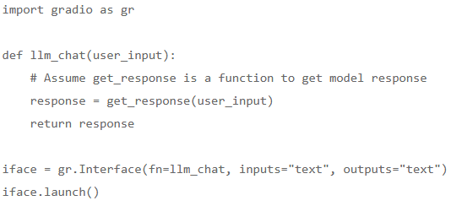
In this Gradio example, a function llm_chat is defined to process the user input and get the model’s response. A Gradio interface is then created to handle text input and output.

Streamlit Code Snippet:
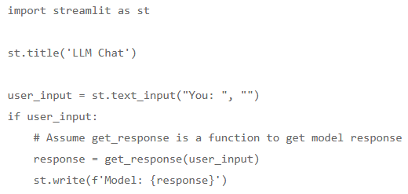
In the Streamlit example, a text input box is created for the user input, and the model’s response is displayed once the user enters a message.

Simplicity and User Interaction
Gradio:
Gradio is hailed for its simplicity and ability to create interactive UIs with minimal code. The framework’s intuitive nature allows developers to focus on the logic rather than the boilerplate code. Great overview for building UI dahsboards with Gradio in EdgeML blog.
Streamlit:
Streamlit also offers a user-friendly platform but with more focus on creating interactive dashboards and visualizations, making it suitable for a broader range of applications.

Customization and Community Support
Streamlit:
Streamlit excels in customization, backed by a vibrant community and extensive documentation. This robust support network can be invaluable when venturing into complex projects.
Gradio:
Gradio, while not as flexible in customization, holds its own with a user-centric approach, focusing on delivering interactive UIs.

Security Considerations
Gradio:
Gradio steps up with security features like password protection and encryption, ensuring a secure environment for application deployment.
Streamlit:
Security features in Streamlit weren’t as prominently mentioned, suggesting a potential area for further investigation for developers concerned with security.

Comparison of Gradio vs Streamlit as Frameworks for you LLM App:
Gradio and Streamlit serve as powerful allies for developers in the journey of machine learning web application development. Gradio shines in creating simple, interactive UIs while Streamlit broadens the horizon with advanced customization and a strong community backbone.
Pros of Gradio:
- Ease of use and interactive UI creation.
- Security features like password protection and encryption.
Pros of Streamlit:
- Extensive customization and integration options.
- Vibrant community and comprehensive documentation.
- Big ecosystem and freeedom for developers
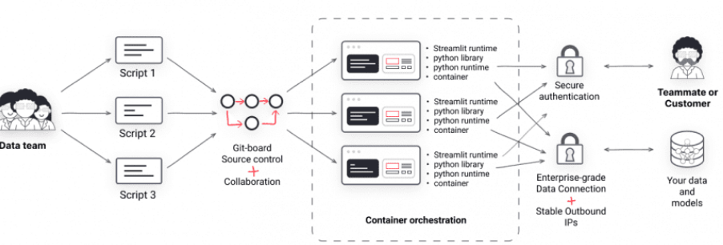
Cons of Gradio:
- Limited advanced customization features.
Cons of Streamlit:
- Security features not highlighted to the extent as in Gradio.
Fields | Gradio | Streamlit
Best Use Case | Interactive UIs for machine learning models | Interactive dashboards and visualizations
Complexity | Lower | Moderate
Ecosystem | Smaller community, limited integrations | Larger community, extensive integrations
Target Group | More towards data scientists | Both software developers and data scientists
Popularity | Growing but less popular | More popular, larger community and support
Deployment | Maximal simplified deployment process to HG! | Flexible deployment options
Customization | Basic customization | Advanced customization
Documentation | Adequate | Extensive
Learning Curve | Easier | Moderate
Model Integration | Simplified model integration | Flexible model integration
Main Features | – Ease of use  – Interactive UI creation  – Security features like password protection and encryption | – Advanced customization and integration options  – Strong community and documentation support  – Ideal for creating interactive dashboards and visualizations
Gradio and Streamlit are both popular frameworks for developing LLM and generative AI applications
Summary
This comprehensive dive aims to equip developers with the knowledge to navigate the choice between Gradio and Streamlit, aligning with their project demands and personal preferences.
Gradio and Streamlit are powerful frameworks designed to facilitate the development of web applications, especially in the context of machine learning and data science. While both are Python-based and user-friendly, they cater to slightly different audiences and project requirements.
Gradio shines with its ease of use and is particularly friendly for data scientists and individuals with limited web development experience. It simplifies the process of creating interactive user interfaces for machine learning models and offers basic customization along with security features like password protection and encryption.
On the other hand, Streamlit is known for its flexibility and extensive customization options, making it a preferred choice for both software developers and data scientists. It’s well-suited for creating interactive dashboards and visualizations. Streamlit also boasts a larger community and more extensive documentation, which can be invaluable for troubleshooting and exploring advanced functionalities.
The choice between Gradio and Streamlit would largely depend on the specific needs of the project. For simpler, interactive UI-focused applications, Gradio might be the better choice. Conversely, for projects requiring advanced customization, interactive dashboards, and a strong community support, Streamlit could be more fitting.
In a nutshell, both frameworks are robust and capable, each with its unique set of features and advantages. The comparison provided aims to equip developers with a clearer understanding to make an informed decision based on their project demands and personal or team expertise. As we see more and more exciting integrations of GenAI and LLMs across industries (as in a recent example of SPOT with LLM integration), the importance of these frameworks is expected to grow.

Introduction:
Docker lets you create consistent, portable, and isolated environments, making it essential for LLMOps (Large Language Models Operations). By encapsulating various LLM applications and their dependencies in containers, Docker simplifies deployment, ensures cross-system compatibility, and streamlines testing.
In this tutorial, you will learn how to build a “document Q&A” chatbot application and deploy it to the cloud using Docker. We will use Gradio for the user interface, LlamaIndex for orchestration, LlamaParse for parsing documents, Mixedbread AI for embeddings, Groq for accessing large language models, Docker for packaging the application and its dependencies, and Hugging Face Spaces for deploying the application to the cloud.
This tutorial is designed to be straightforward, allowing anyone with limited knowledge of how AI applications work to build it for free.
- Deployment strategy:
There are two main approaches to developing and deploying AI applications:
- Fully open source: This approach emphasizes privacy and data protection.
- Fully closed source: This method involves integrating multiple APIs and cloud services.
Both approaches have advantages and disadvantages. In our case, we have chosen the second approach, integrating multiple AI services. This allows us to build a fast AI application that takes only a few seconds to build and deploy. Our main focus is to reduce the Docker image size, which can be effectively achieved by integrating multiple AI services.
Check out the Local AI with Docker, n8n, Qdrant, and Ollama tutorial to build an LLM application using open-source tools and frameworks for enhanced privacy!
We will build a general-purpose Q&A chatbot that allows users to upload documents and chat with them in real time. It is quite similar to Google’s NotebookLM.
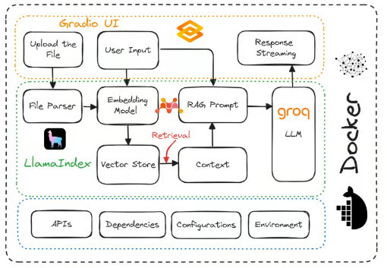

1. Setting Up the Environment
Before building the LLM app, we need to download and install Docker from the official website.
- Install Docker on your local system using the default options.
- Next, create a project directory using your favorite IDE and add a .env file. We will use this file to store the API keys for LlamaCloud, MixedBread AI, and Groq Cloud.
- After that, sign up for LlamaCloud and generate your API key. We will use LlamaCloud to parse various text formats, including Excel, txt, Word, and PDFs.
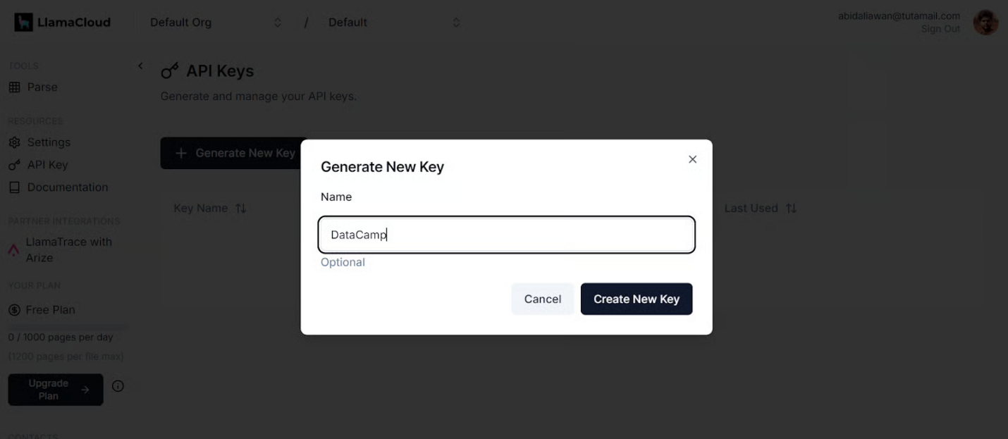
Generating a new key in LlamaCloud
- Next, sign up for MixedBread AI and generate your API key. We will use this key to access their top-of-the-line embedding model for free.
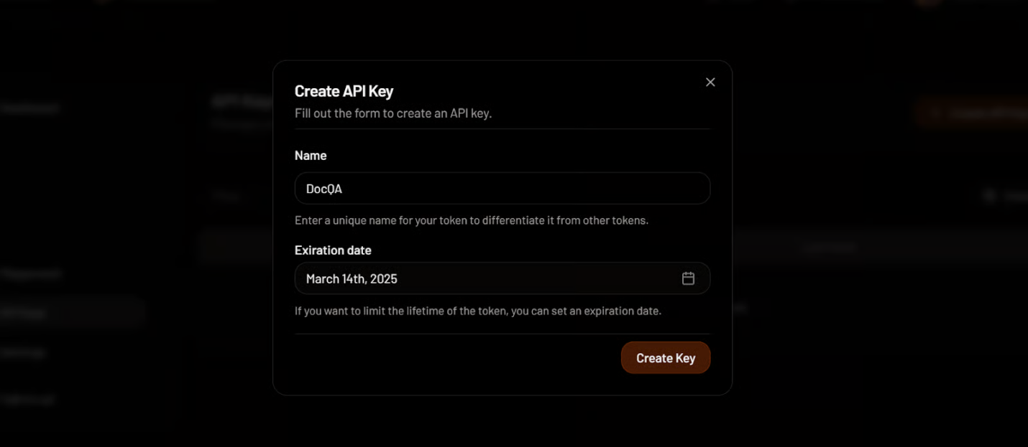
Creating an API key in MixedBread
- Go to GroqCloud and sign up to generate your API key at no cost. We will use GroqCloud to access high-speed LLMs.
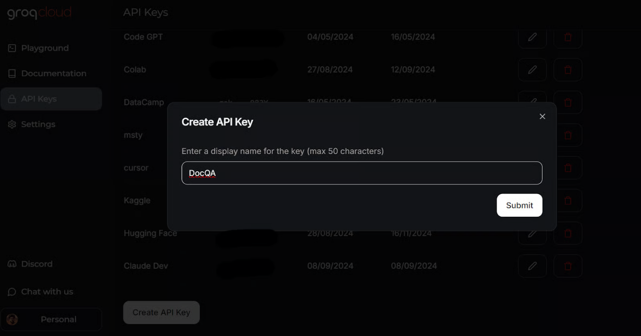
Creating an API key in GroqCloud
Learn everything about GroqCloud by reading the article on Groq LPU Inference Engine. You will learn about the Groq API and its features with code examples. Additionally, learn how to build context-aware AI applications using the Groq API and LlamaIndex.
This is how your .env file should look like:
LLAMA_CLOUD_API_KEY=llx-XXXXXX
GROQ_API_KEY=gsk_XXXXXXX
MXBAI_API_KEY=emb_XXXXXX
Remember to add the .env file to your .gitignore file to avoid accidentally exposing your API keys to the public.

2. Building the LLM Application
We will now create a Python script called app.py and add the user interface components while integrating all the AI services using LlamaParser to develop the Retrieval-Augmented Generation (RAG) pipeline with LlamaIndex.
The app.py script will do the following:
- Load all necessary Python packages.
- Securely load all API keys from the .env file.
- Initialize the LlamaParser using the LlamaCloud API key.
- Define a file extractor that handles various common file extensions.
- Initialize the embedding model using the MixedBread AI API key, specifically the model named mixedbread-ai/mxbai-embed-large-v1.
- Initialize the large language model using the Groq Cloud API key and the model named llama-3.1-70b-versatile.
Next, it will implement the following Python functions:
- load_files(): This function will load the files, parse them using LlamaParser, convert them into embeddings, and store them in the vector store. Exception handling will be included to manage cases where non-files or unsupported file formats are uploaded.
- respond(): This function will take user input, retrieve content from the vector store, and use it to generate a response utilizing the Groq model. The response generation will be in streaming format, and exception handling will be included if no files have been uploaded.
Finally, it will build the UI components, including a file uploader, buttons, a chat box, and the overall chat interface.
Learn more about the LlamaIndex framework by following the more straightforward LlamaIndex tutorial.
Here’s the app.py script:
import os
import gradio as gr from llama_index.core import SimpleDirectoryReader, VectorStoreIndex from llama_index.embeddings.mixedbreadai import MixedbreadAIEmbedding from llama_index.llms.groq import Groq from llama_parse import LlamaParse
# API keys
llama_cloud_key = os.environ.get("LLAMA_CLOUD_API_KEY")
groq_key = os.environ.get("GROQ_API_KEY")
mxbai_key = os.environ.get("MXBAI_API_KEY")if not (llama_cloud_key and groq_key and mxbai_key):
raise ValueError(
"API Keys not found! Ensure they are passed to the Docker container."
)
# models name
llm_model_name = "llama-3.1-70b-versatile"
embed_model_name = "mixedbread-ai/mxbai-embed-large-v1"
# Initialize the parser
parser = LlamaParse(api_key=llama_cloud_key, result_type="markdown")
# Define file extractor with various common extensions
file_extractor = {
".pdf": parser,
".docx": parser,
".doc": parser,
".txt": parser,
".csv": parser,
".xlsx": parser,
".pptx": parser,
".html": parser,
".jpg": parser,
".jpeg": parser,
".png": parser,
".webp": parser,
".svg": parser,
}
# Initialize the embedding model
embed_model = MixedbreadAIEmbedding(api_key=mxbai_key, model_name=embed_model_name)
# Initialize the LLM
llm = Groq(model="llama-3.1-70b-versatile", api_key=groq_key)

# File processing function
def load_files(file_path: str):
global vector_index
if not file_path:
return "No file path provided. Please upload a file."

valid_extensions = ', '.join(file_extractor.keys())
if not any(file_path.endswith(ext) for ext in file_extractor):
return f"The parser can only parse the following file types: {valid_extensions}"

document = SimpleDirectoryReader(input_files=[file_path], file_extractor=file_extractor).load_data()
vector_index = VectorStoreIndex.from_documents(document, embed_model=embed_model)
print(f"Parsing completed for: {file_path}")
filename = os.path.basename(file_path)
return f"Ready to provide responses based on: {filename}"

# Respond function
def respond(message, history):
try:
# Use the preloaded LLM
query_engine = vector_index.as_query_engine(streaming=True, llm=llm)
streaming_response = query_engine.query(message)
partial_text = ""
for new_text in streaming_response.response_gen:
partial_text += new_text
# Yield an empty string to cleanup the message textbox and the updated conversation history
yield partial_text
except (AttributeError, NameError):
print("An error occurred while processing your request.")
yield "Please upload the file to begin chat."

# Clear function
def clear_state():
global vector_index
vector_index = None
return [None, None, None]

# UI Setupwith gr.Blocks(
theme=gr.themes.Default(
primary_hue="green",
secondary_hue="blue",
font=[gr.themes.GoogleFont("Poppins")],
),
css="footer {visibility: hidden}",
) as demo:
gr.Markdown("# DataCamp Doc Q&A 🤖📃")
with gr.Row():
with gr.Column(scale=1):
file_input = gr.File(
file_count="single", type="filepath", label="Upload Document"
)
with gr.Row():
btn = gr.Button("Submit", variant="primary")
clear = gr.Button("Clear")
output = gr.Textbox(label="Status")
with gr.Column(scale=3):
chatbot = gr.ChatInterface(
fn=respond,
chatbot=gr.Chatbot(height=300),
theme="soft",
show_progress="full",
textbox=gr.Textbox(
placeholder="Ask questions about the uploaded document!",
container=False,
),
)

# Set up Gradio interactions
btn.click(fn=load_files, inputs=file_input, outputs=output)
clear.click(
fn=clear_state, # Use the clear_state function
outputs=[file_input, output],
)
# Launch the demo
if __name__ == "__main__":
demo.launch()
- Run the above Python file to start the Gradio server using the following command in your terminal:
$ python app.py
Output:
- You can access the Grodio UI by copying and pasting the generated URL into the browser. Then, you can upload a file and start asking questions about it.
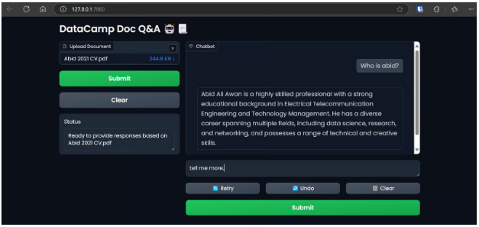
accessing the Gradio app on the browser.
We use LlamaIndex to deploy and build our LLM application for this tutorial. You can build a similar application with LangChain by taking the Developing LLM Applications with LangChain short course.

3. Creating the Dockerfile
- In your project, create a Dockerfile to package the application script, Python dependencies, and server configurations while initializing the Gradio server.
The Dockerfile will perform the following tasks:
- Set up a Python 3.9 environment.
- Define the working directory.
- Copy the requirements.txt file to the /app directory. This file contains the names of all the required Python packages.
- Install all the dependencies specified in the requirements.txt file.
- Copy the app.py file to the /app directory.
- Expose the port and set the Gradio server URL.
- Run the application file to start the server.
How the Dockerfile should look:
# Dockerfile

# Use the official Python image with the desired version
FROM python:3.9-slim

# Set the working directory inside the container
WORKDIR /app

# Copy the requirements file to the working directory
COPY requirements.txt /app

# Install the dependencies
RUN pip install --no-cache-dir -r requirements.txt

# Copy the rest of the application code to the working directory
COPY app.py /app

# Expose the port that Gradio will run on (default is 7860)
EXPOSE 7860

ENV GRADIO_SERVER_NAME="0.0.0.0"

# Command to run your application
CMD ["python", "app.py"]
- And this is how the requirements.txt file looks like. Add it to your project as well:
gradio
llama-index-embeddings-mixedbreadai
llama-index-llms-groq
llama-index

4. Building the Docker Image and Running the Container
- Type the following command in the terminal to build the docqa docker image. It will use the Dockerfile to create the Docker image.
$ docker build -t docqa .
We can see the logs of the processes taking place while building the Docker image:
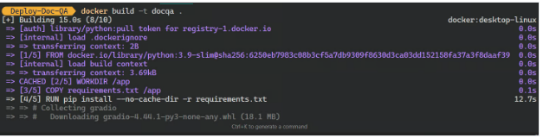
Building the LLM Docker image.
- Once the image is successfully built, go to the Docker Desktop, click on the Images tab, and click on the Docker image to see the logs and various instructions for running the image.
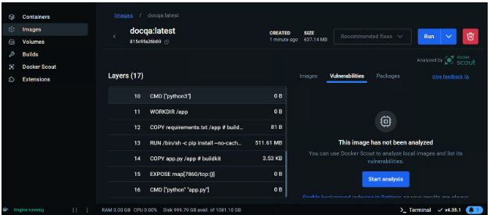
Viewing the Docker image on the Docker Desktop.
We will now run the Docker container locally using the image. We will provide it with the port number, a .env file to set up environment variables, the Docker container name, and the Docker image tag.
- Run the following command in your terminal:
$ docker run -p 7860:7860 --env-file .env --name docqa-container docqa
Once the container starts running, you can access the Gradio app by pasting the URL, in this case, http://0.0.0.1:7860/ in the browser.
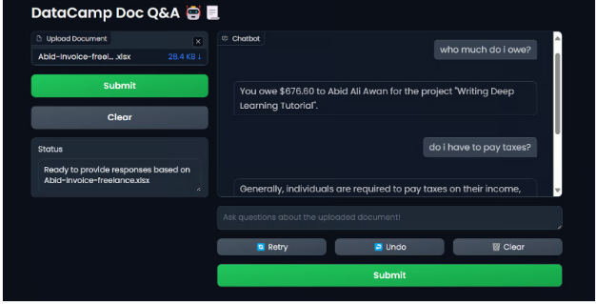
Testing the Docker container LLM application.
- To view the information on all the containers running locally, type the following command:
$ docker ps
Output:
CONTAINER ID IMAGE COMMAND CREATED STATUS PORTS NAMES
ff2a11da13d7 docqa "python app.py" 17 seconds ago Up 16 seconds 0.0.0.0:7860->7860/tcp docqa-container
- You can stop the Docker container using the stop command:
$ docker stop docqa-container
- You can also remove it using the rm command:
$ docker rm docqa-container
Once we have a Docker image, we can deploy our LLM application anywhere: GCP, AWS, Azure, or any cloud server that supports Docker deployment.

5. Deploying the LLM Application to Hugging Face Using Docker
To simplify things for beginners, we will deploy the app using Docker on the Hugging Face Cloud (Spaces).
- Go to the Hugging Face dashboard, click on the profile image, and select + New Space.
- Give your Space a name, add the short description, select the license and SDK, and create the Space repository.
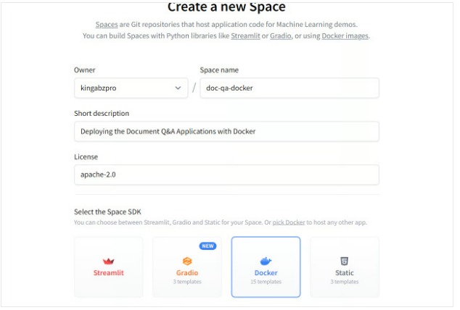
Creating the new Hugging Face Space using Docker.
Once the Space repository is created, you’ll receive instructions on how to clone it and add the necessary files.
- To clone the repository, use the following command (update the URL to the one pointing to your Space):
$ git clone https://huggingface.co/spaces/kingabzpro/doc-qa-docker
- Copy and paste all the files from the project directory to the new repository:
This is how your project directory should look with all the files. Always ensure you do not push the .env file, so add it to the .gitignore.
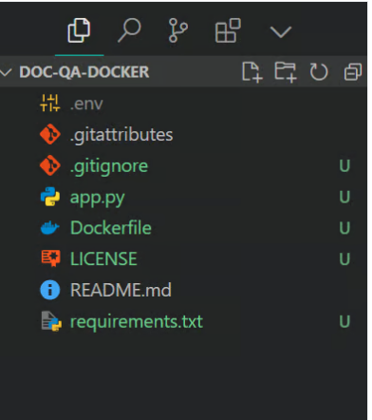
- Stage the files, commit with a message, and then push it to the Hugging Face Space:
$ git add .
$ git commit -m "Deploying the App"
$ git push
Output:
Enumerating objects: 8, done.
Counting objects: 100% (8/8), done.
Delta compression using up to 16 threads
Compressing objects: 100% (7/7), done.
Writing objects: 100% (7/7), 7.60 KiB | 7.60 MiB/s, done.
Total 7 (delta 0), reused 0 (delta 0), pack-reused 0 (from 0)
To https://huggingface.co/spaces/kingabzpro/doc-qa-docker
afb20ad..5ca6388 main -> main
- Go to your Hugging Face Space to access the application. It will build the Docker image and then serve the application:
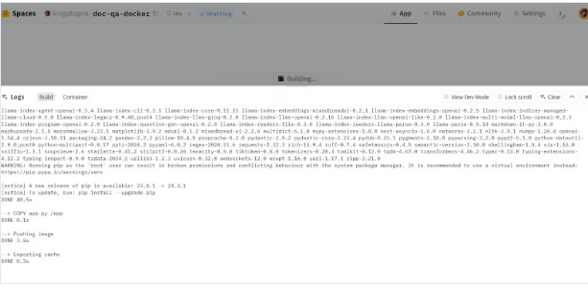
Building the Docker image in the Hugging Face Cloud.
If you see an error like the one below, don't worry. It is due to missing environment variables. All we have to do is set up those variables in the Hugging Face Space.
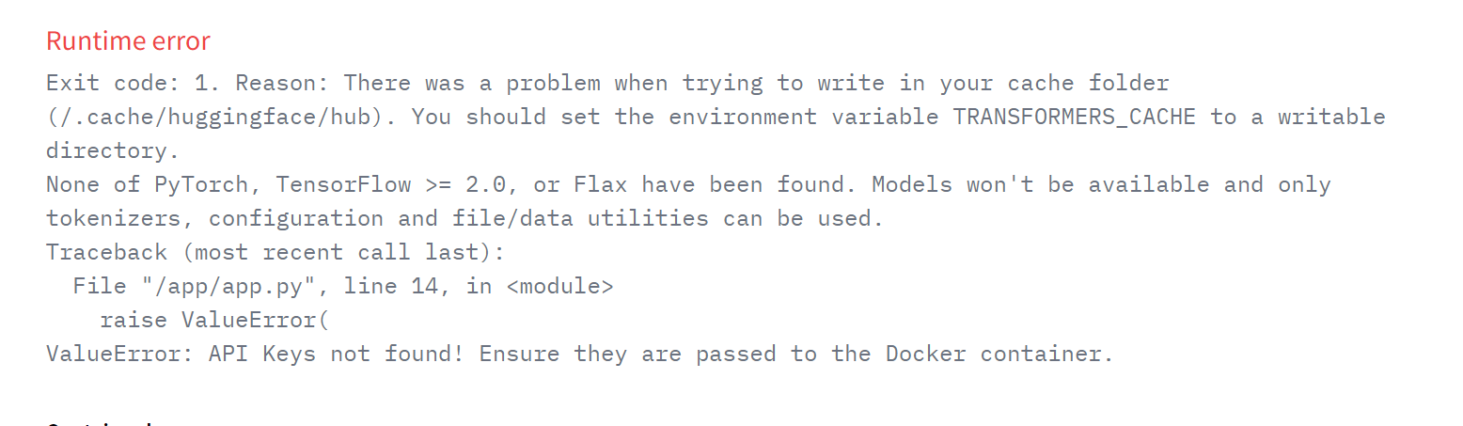
Runtime error on the deployed app.
- To add a new environment variable in your Space, go to Settings, scroll down, and click the New secret button. Then, provide the name and value for the environment value, as shown below. In this case, we are adding the necessary API keys:
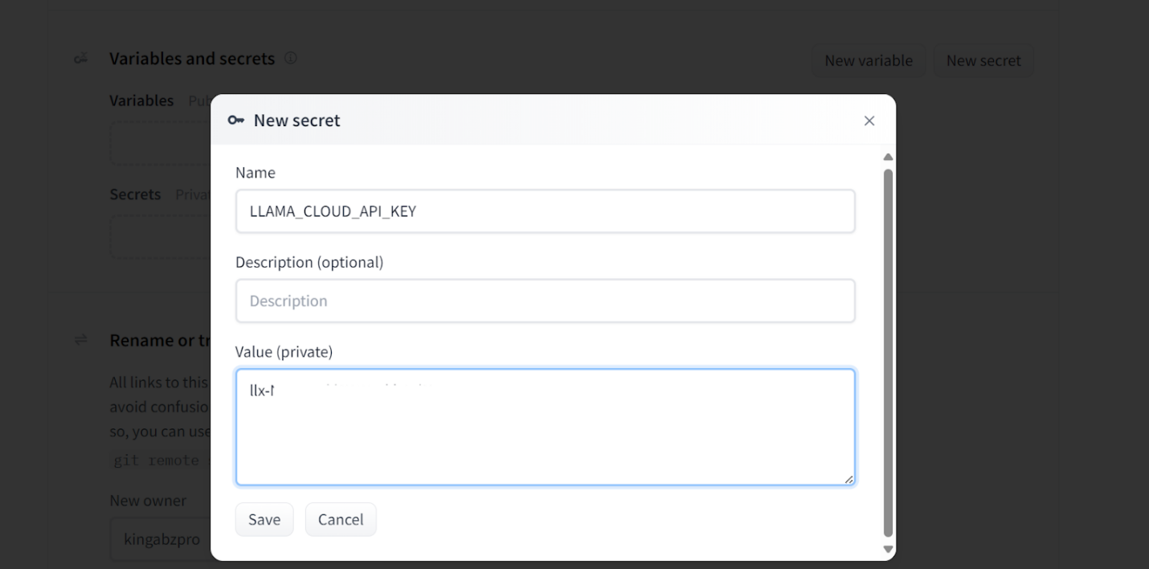
Adding secrets to the deployed app
This is how your secrets should look after adding all the necessary API keys as environment variables:
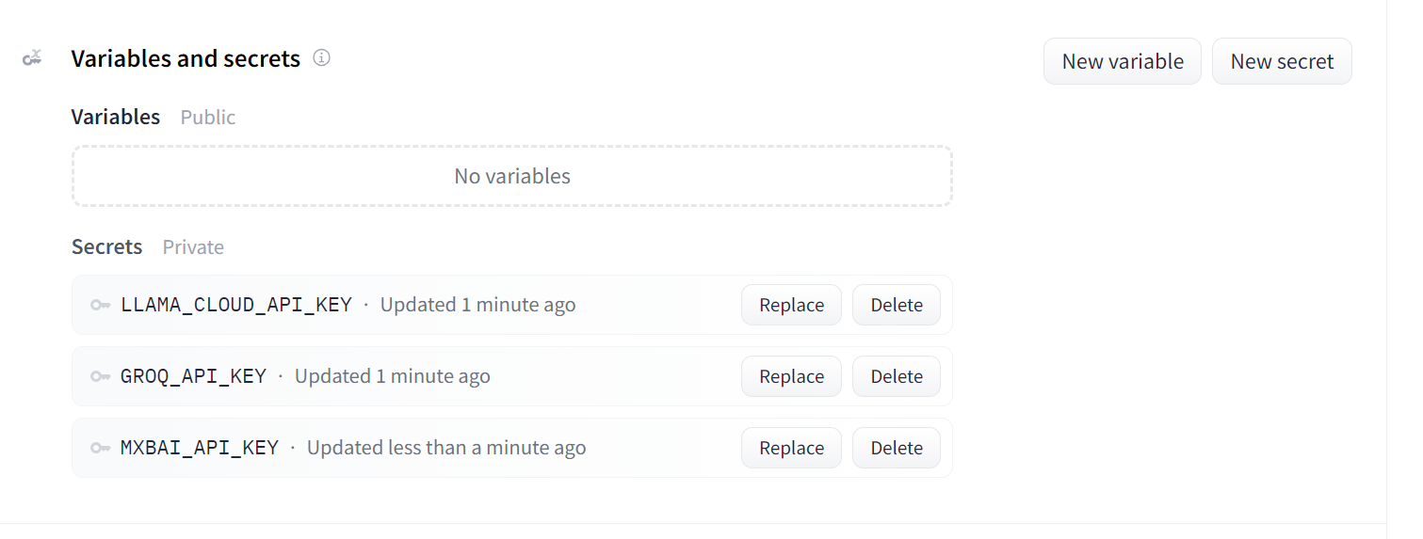
Secrets for the deployed app.
Once you have set up the secrets, the app will restart automatically, and you should see the app running. Use it and enjoy your document Q&A application on the cloud!
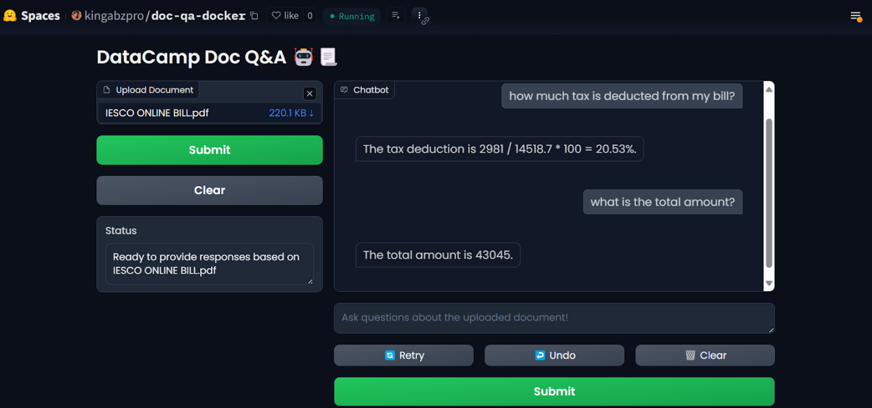
LLM app on the Hugging Face Spaces.
To reproduce the results, all files and configurations can be found in the GitHub repository: kingabzpro/Deploy-Doc-QA.

6. Monitoring the Deployed Application
Using AI services has advantages: You don't have to deploy or manage any services, you get high throughput, and you get a dashboard with the logs.
Your LlamaCloud dashboard logs all the documents that have been parsed. You can check out the history or request and compare usage.
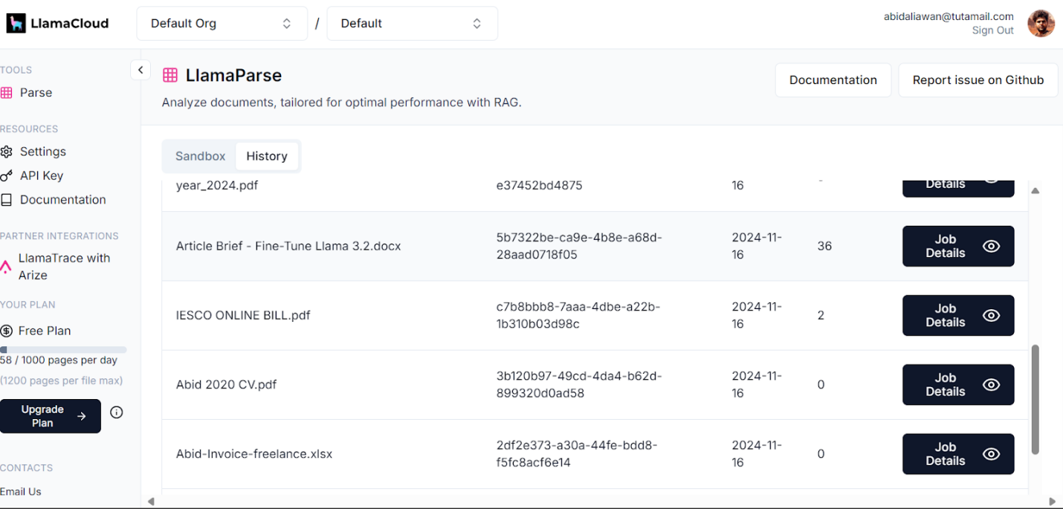
Llama Cloud dashboard.
Similarly, you can also check the number of tokens we used for the embedding model and the number of requests generated.
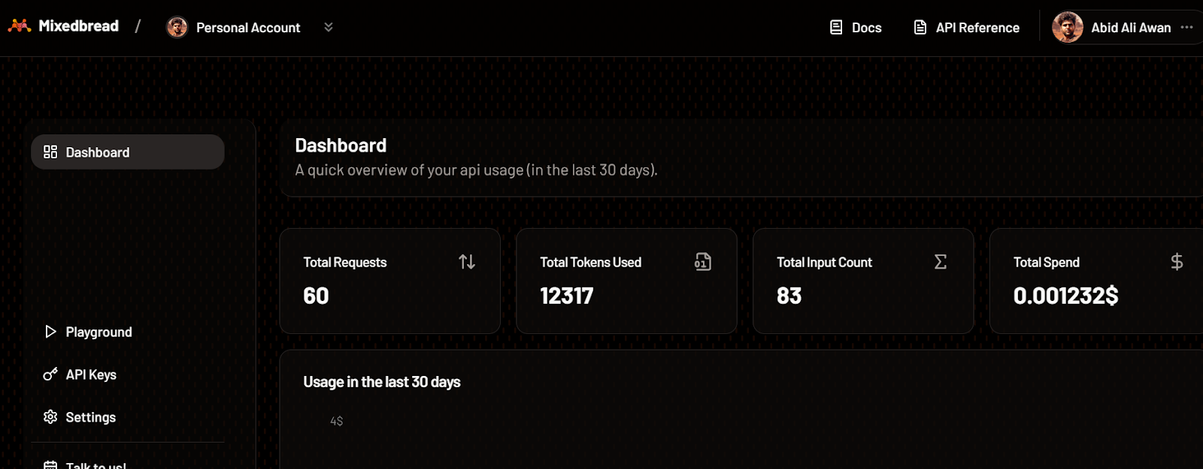
Mixedbread dashboard.
The most detailed logs of each API can be found on the GroqCloud, with information about the latency, the number of tokens, the AI key, and the request ID for you to debug the system.
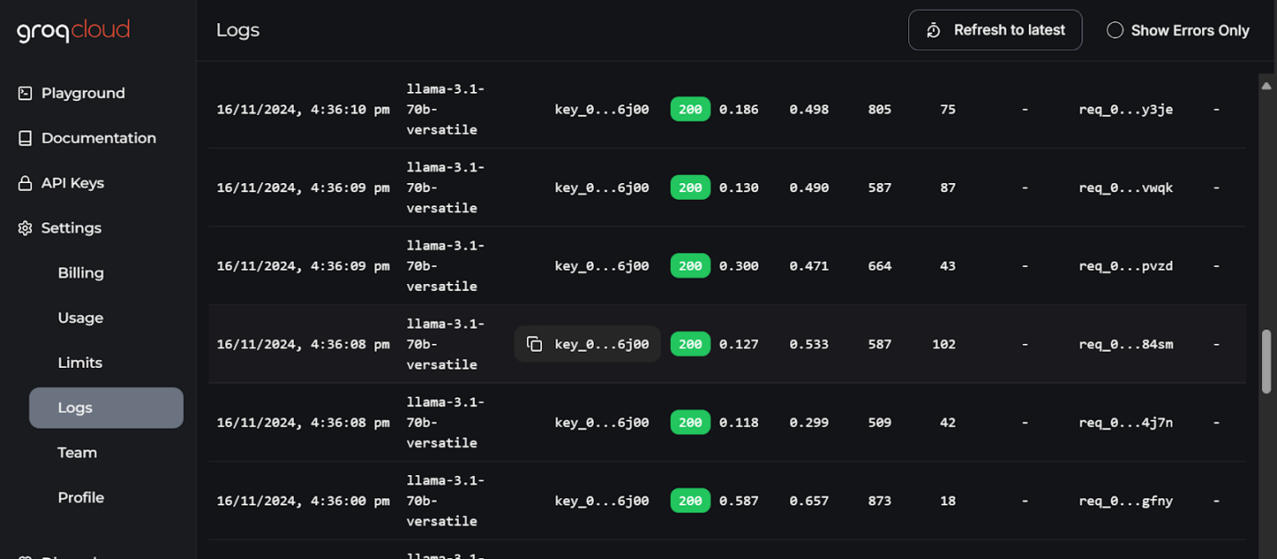
GroqCloud logs. Image source: GroqCloud

What You're Aiming For
Package and Serve a LangChain Agent with a Frontend

Instructions
Step 1. Create a simple LangChain Agent
We define a small agent that can answer questions (here using OpenAI as an example, but you can plug in any LLM).
agent.py

from langchain_openai import ChatOpenAI
from langchain.agents import initialize_agent, load_tools

# Load an LLM
llm = ChatOpenAI(model="gpt-3.5-turbo")

# Load some tools (example: search and math)
tools = load_tools(["serpapi", "llm-math"], llm=llm)

# Initialize the agent
agent = initialize_agent(
tools, llm, agent="zero-shot-react-description", verbose=True
)

Step 2. Serve the agent with LangServe
We expose the agent as a REST API using LangServe.
server.py

from langserve import serve
from agent import agent

# Expose the agent as an API
serve(agent, port=8000)

Run the server:
- python server.py

The agent is now available at http://localhost:8000/

Step 3. Build the frontend with Gradio
We create a simple UI that calls the LangServe API.
app.py

import requests
import gradio as gr

API_URL = "http://localhost:8000/invoke"

def chat_with_agent(user_input):
payload = {"input": user_input}
response = requests.post(API_URL, json=payload)
return response.json().get("output", "Error")

demo = gr.Interface(
fn=chat_with_agent,
inputs=gr.Textbox(lines=2, placeholder="Ask me anything..."),
outputs="text",
title="LangChain Agent with Gradio"
)

demo.launch(server_name="0.0.0.0", server_port=7860)

Run:
- python app.py

You now have a Gradio UI that communicates with your agent through LangServe
Step 4. Dockerize (optional but recommended )
Dockerfile

FROM python:3.10-slim

WORKDIR /app
COPY requirements.txt .

RUN pip install --no-cache-dir -r requirements.txt

COPY . .

EXPOSE 7860
EXPOSE 8000

CMD ["python", "server.py"]

requirements.txt

langchain
langserve
gradio
requests
openai

Build & run:

docker build -t langchain-agent .
docker run -p 8000:8000 -p 7860:7860 langchain-agent

At the end of this checkpoint you will have:
- A LangChain Agent served via LangServe (backend).
- A Gradio frontend connected to the agent.
- A Dockerized deployment ready for scaling and sharing.

